CS 590 Module Two Assignment: Relational Databases and PostgreSQL
Ashanti Terrell
Table Structure and Data Types
The provided schema creates a PostgreSQL table named public.nutdes for the Nutrient Descriptions data set. The table contains six columns: Nutrient code, Nutrient description, Nutrient description abbrev, Nutrient unit, Date added, and Last modified. Each row represents one nutrient definition used by the nutrient database. The table is narrow and efficient because it stores descriptive metadata about nutrients rather than large transactional records.
Column | Data Type | Purpose and Assessment
Nutrient code | int4 NOT NULL | Stores the numeric nutrient identifier, such as 203 for Protein. The integer type is appropriate because the values are whole-number codes. NOT NULL helps ensure each nutrient has an identifying code.
Nutrient description | varchar(50) NOT NULL | Stores the full nutrient name, such as Protein or Total Fat. varchar(50) is efficient for short text labels while allowing reasonable growth for longer nutrient names.
Nutrient description abbrev | varchar(50) NOT NULL | Stores a shorter label or abbreviation, such as Pro, Fat, or Carb. A variable-length text field is appropriate because abbreviations vary in length.
Nutrient unit | varchar(50) NOT NULL | Stores the unit of measurement, such as g, kcal, mg, or IU. varchar(50) supports common units while avoiding unnecessary storage.
Date added | date NULL | Stores the date the nutrient record was added. The date type supports accurate date filtering and sorting without storing unnecessary time values.
Last modified | date NULL | Stores the most recent modification date. NULL is appropriate because some records may not have a later modification date available.
The schema does not define a primary key, foreign key, or relationship constraint. However, Nutrient code appears to function as the logical unique identifier and would be a strong candidate for a primary key if the database were expanded. This would improve data integrity and support relationships with a related nutrient values table. Overall, the selected data types are scalable for this assignment because they use integer, variable character, and date fields that match the actual data. The structure supports accuracy by requiring the core descriptive fields while allowing date fields to be blank when needed.
Database Implementation and ETL Process
To implement the schema in PostgreSQL, I used the public schema and created the nutdes table from the provided SQL file. I also created a new PostgreSQL user so the database work could be completed using controlled access instead of relying only on the default administrator account. The database was then instantiated in DBeaver/Codio, and the Module_Two_Nut_Descs.csv file was loaded into the table.
The ETL process included extracting the nutrient description records from the CSV file, transforming the date fields from the CSV format into PostgreSQL date values, and loading the data into public.nutdes. The CSV contained 19 rows and 6 columns. After import, I verified the results by running a SELECT query in DBeaver to confirm the nutrient records appeared in the table.
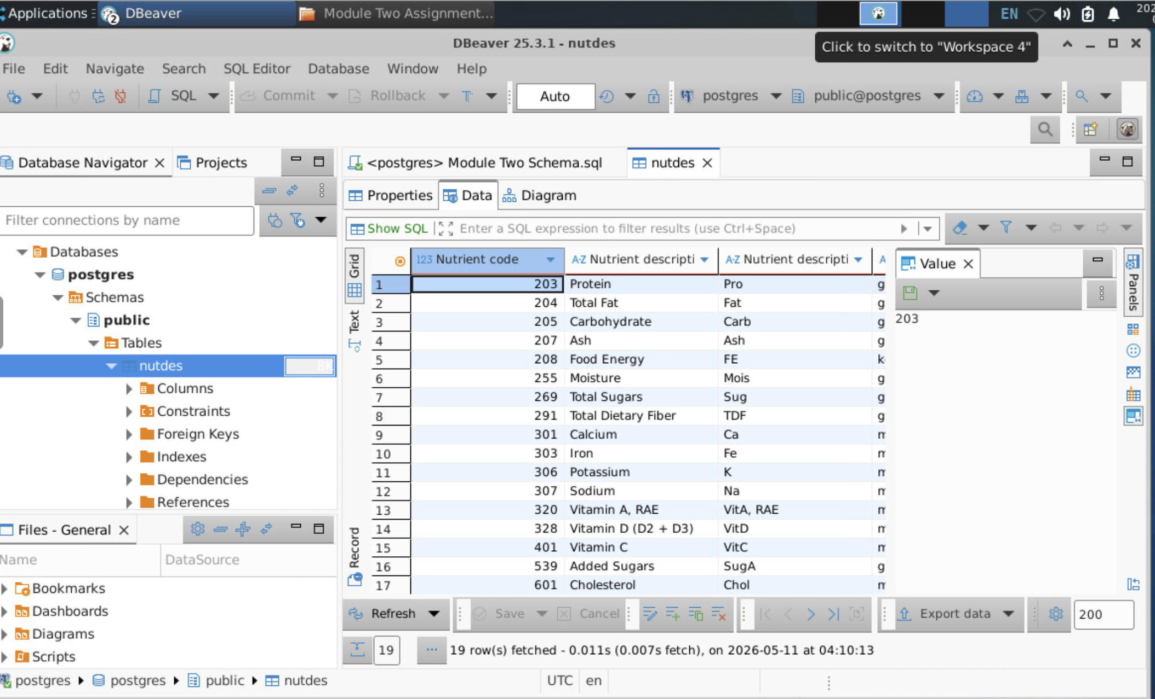
Backup File and GitHub Submission
After confirming that the data was loaded successfully, I created a PostgreSQL backup file using the pg_dump tool. The backup file should be named module2-1-Terrell and uploaded to the private GitHub repository on the Module Two branch. This backup step supports version control because it preserves the database structure and loaded data in a reusable format.
The following commands reflect the implementation workflow used for this assignment:
CREATE USER module2_user WITH PASSWORD 'password';
CREATE DATABASE module2_nutrients OWNER module2_user;
\c module2_nutrients;
\i module_two_schema.sql;
\copy public.nutdes FROM 'Module_Two_Nut_Descs.csv' WITH (FORMAT csv, HEADER true);
SELECT * FROM public.nutdes;
pg_dump -U module2_user -d module2_nutrients -F c -f module2-1-Terrell.backup

I kept getting errors from the terminal

Conclusion
The Module Two PostgreSQL assignment demonstrates the full workflow of creating a relational table, loading data through ETL, validating the table contents, and creating a database backup for version control. The nutdes table uses data types that match the nutrient description data and provide an efficient foundation for future relationships with nutrient values data. Adding a primary key to Nutrient code in a production version would strengthen data integrity and make the design more relationally complete.

